SAFEGRID-AI: AN EXPLAINABLE MULTI-AGENT SYSTEM FOR DYNAMIC POWER ROUTING
Block Diagrams (all)
Department of Computer Science and Engineering, TKR College of Engineering and Technology (Autonomous)
Batch A13 (CSE-A) · Academic year [ACADEMIC YEAR]
Table 1: Project team
S.No. | Student name | Roll number
1 | DISHA KAUSHAL | 23K91A0563
2 | BOLLAM RAKESH | 23K91A0542
3 | CHINNOLLA RAVINDHAR | 23K91A0554
4 | AFFAN MOHAMMED RAMY | 23K91A0505

Project guide: CHANDRASHEKAR
Chapter and section numbers quoted in the text (for example Section 6.6 or Chapter 8) refer to the full project report, 17.Final Document. Figures and tables in this document are numbered from 1.

1. INDEX OF DIAGRAMS
Every diagram is generated from the real design by scripts/make_diagrams.py (matplotlib, 150 dpi) and mirrors the code in backend/app/ (api, services, simulation, agents, llm, safety, grid and database packages).
Table 2: Diagrams in this document
No. | Diagram | Image file
1 | System architecture | docs/diagrams/01_system_architecture.png
2 | High-level workflow | docs/diagrams/02_high_level_workflow.png
3 | Data flow diagram, level 0 | docs/diagrams/03_dfd_level0.png
4 | Data flow diagram, level 1 | docs/diagrams/04_dfd_level1.png
5 | Data flow diagram, level 2 | docs/diagrams/05_dfd_level2.png
6 | UML class diagram | docs/diagrams/06_uml_class_diagram.png
7 | Sequence diagram | docs/diagrams/07_sequence_diagram.png
8 | Use-case diagram | docs/diagrams/08_use_case_diagram.png
9 | Entity-relationship diagram | docs/diagrams/09_er_diagram.png
10 | Core algorithm flowchart | docs/diagrams/10_core_algorithm_flowchart.png
11 | Simulated feeder topology | docs/diagrams/11_feeder_topology.png
12 | Hash-chained safety log | docs/diagrams/12_hash_chain.png

2. DIAGRAMS

System architecture
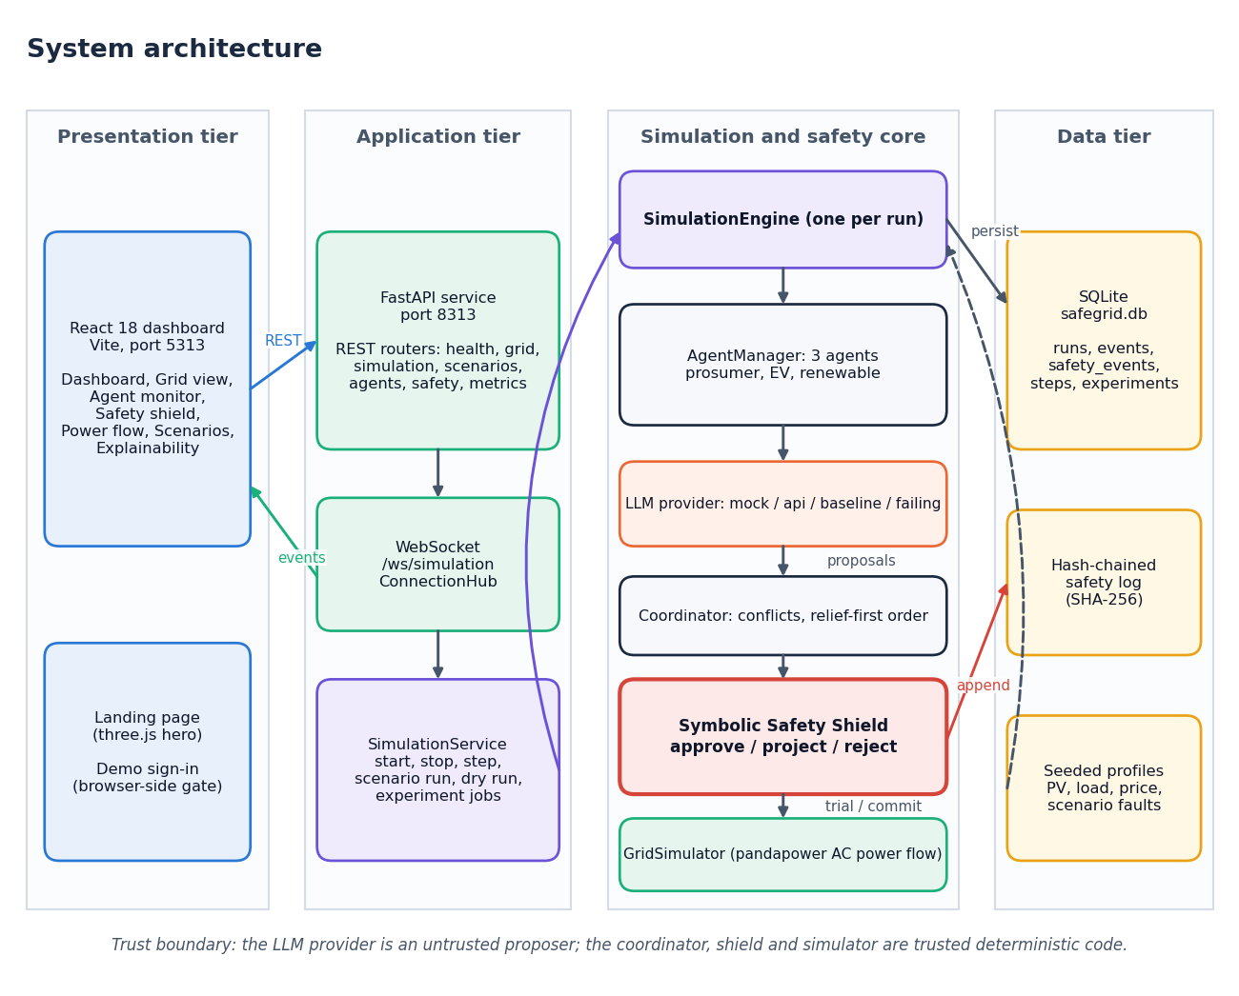
Figure 1: System architecture of SafeGrid-AI
The system has four tiers. The presentation tier is the React 18 console served by Vite on port 5313: a landing page with a three.js hero, a demo sign-in, and seven console screens. The application tier is a FastAPI service on port 8313: REST routers, a WebSocket route (/ws/simulation) that streams events through the ConnectionHub, and SimulationService, which owns the current run, runs scenarios, answers dry-run requests and manages experiment jobs. The simulation and safety core holds one SimulationEngine per run. The engine drives an AgentManager with three agents, whose proposals come from an LLM provider (mock, api, baseline or failing); the coordinator orders the proposals; the Symbolic Safety Shield validates each one; and the GridSimulator runs the pandapower AC power flow for trial and committed states. The data tier is a SQLite file with five tables, the hash-chained safety log, and the seeded profiles and scenario faults. The footnote in the figure states the trust boundary: the LLM provider is an untrusted proposer; the coordinator, shield and simulator are trusted deterministic code.

High-level workflow
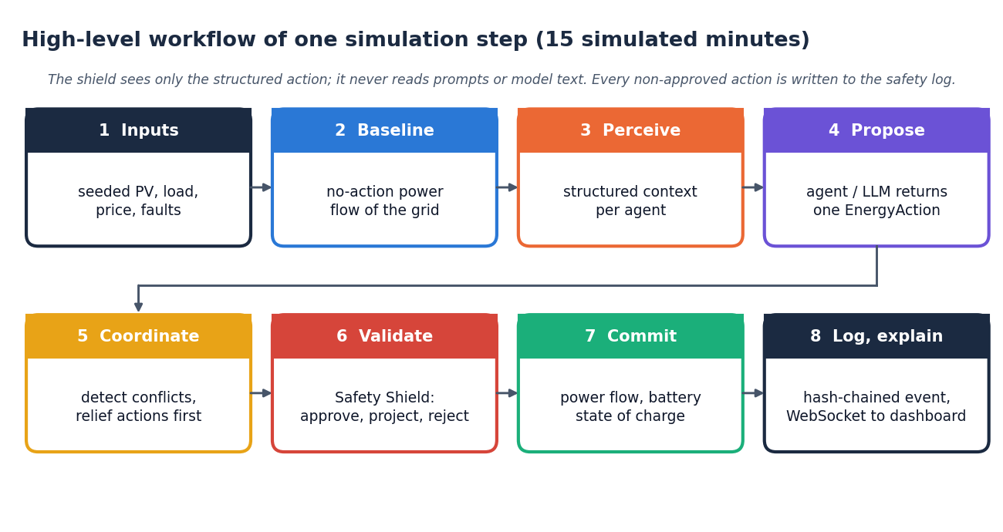
Figure 2: High-level workflow of one simulation step (15 simulated minutes)
One control step has eight stages. (1) Seeded profiles give solar output, household load, price and any scenario fault. (2) A no-action power flow records the grid state if every agent stayed idle; it is the baseline against which later violations are attributed. (3) Each agent perceives a structured context built from its node, its neighbours and the grid limits. (4) Each agent returns one EnergyAction; a provider failure or invalid answer becomes a labelled deterministic fallback. (5) The coordinator detects conflicts and puts relief actions first. (6) The Safety Shield validates the proposals one after another against the cumulative grid state and approves, projects or rejects each. (7) Only the validated set-points are committed: the power flow is run again and battery states of charge are updated. (8) Non-approved decisions are appended to the hash-chained safety log, the step is stored, and events are streamed to the dashboard.

Data flow diagram, level 0
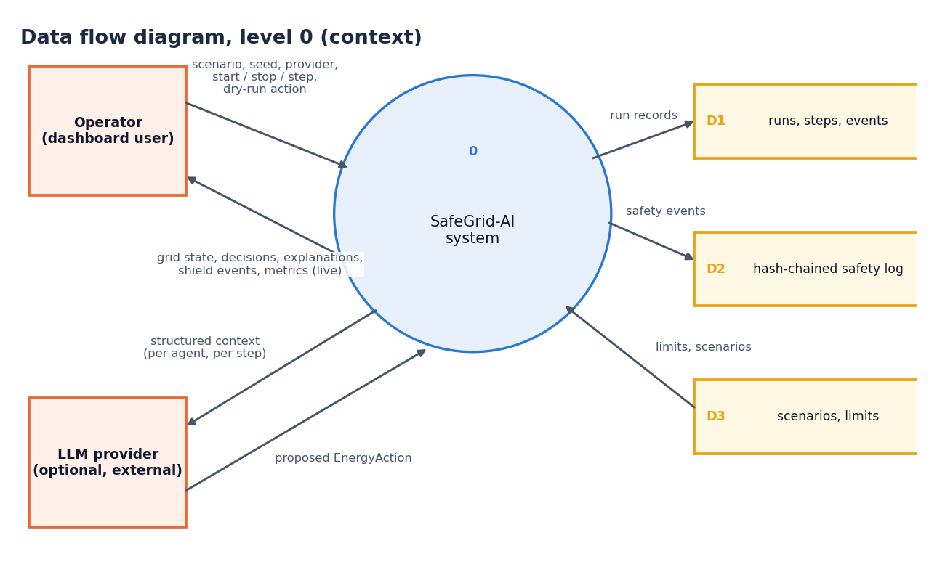
Figure 3: Data flow diagram, level 0 (context diagram)
The context diagram shows SafeGrid-AI as a single process with two external entities. The operator sends the scenario, seed, provider choice, start, stop and step commands and dry-run actions, and receives live grid state, decisions, explanations, shield events and metrics. The optional LLM provider receives the structured context of each agent and returns a proposed EnergyAction. Internally the system writes the run store (runs, steps, events; D1) and the hash-chained safety log (D2), and reads the scenario and constraint configuration (D3).

Data flow diagram, level 1
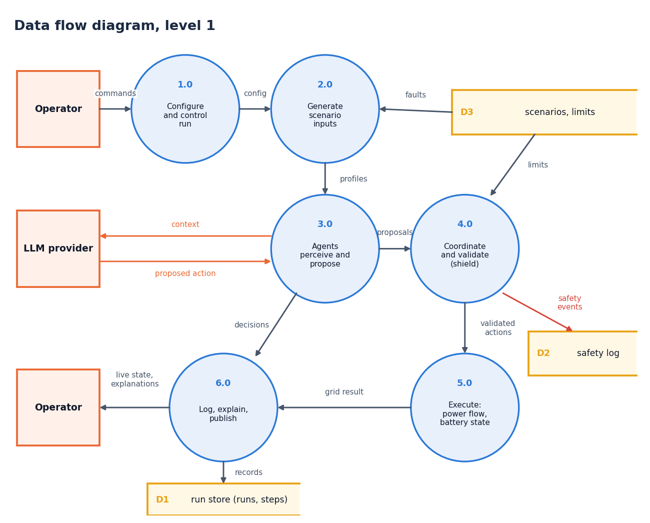
Figure 4: Data flow diagram, level 1
Level 1 splits the system into six processes. Configure and control run (1.0) accepts the operator's commands. Generate scenario inputs (2.0) combines the run configuration with the faults and limits in D3 and produces the seeded profiles. Agents perceive and propose (3.0) exchanges context and proposed actions with the LLM provider. Coordinate and validate (4.0) is the shield: it reads the limits, appends safety events to D2 and passes validated actions on. Execute (5.0) runs the power flow and updates battery states. Log, explain and publish (6.0) writes the run store (D1) and returns live state and explanations to the operator.

Data flow diagram, level 2
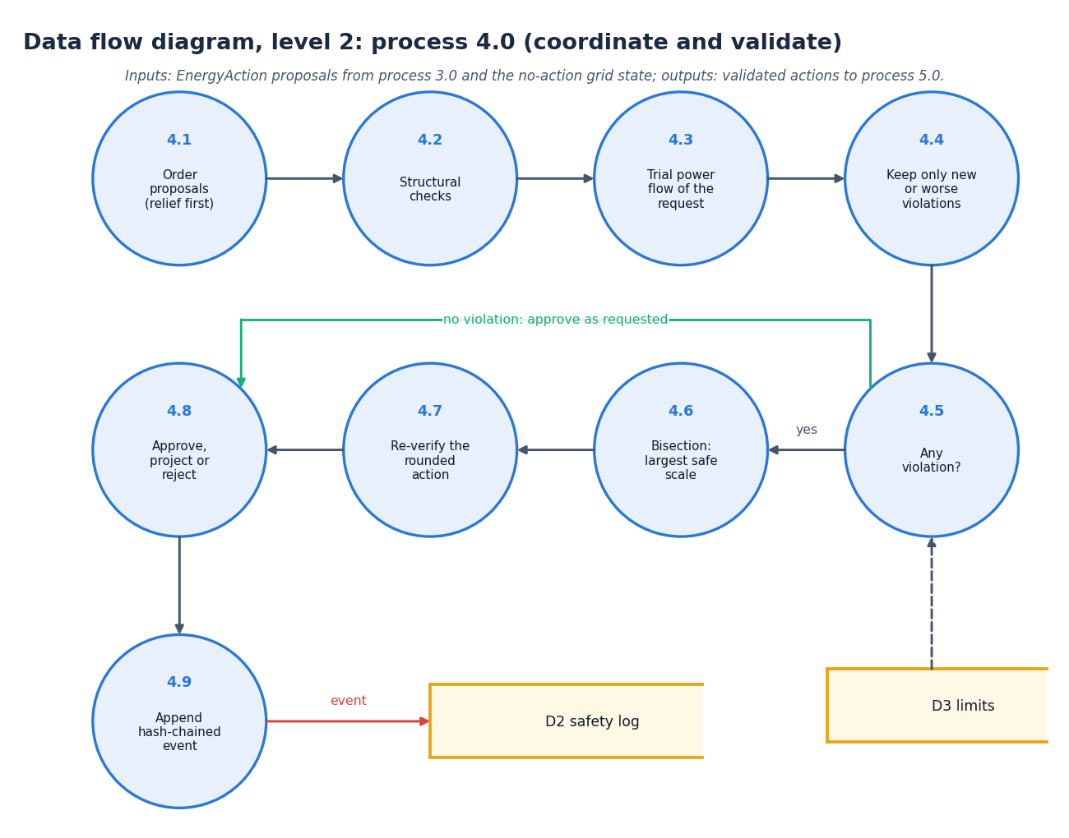
Figure 5: Data flow diagram, level 2: process 4.0 expanded
Level 2 expands the shield process into the steps that SymbolicSafetyShield.evaluate performs. Proposals are first ordered with relief actions first (4.1) and checked structurally (4.2). A trial power flow of the request as proposed (4.3) is compared with the no-action baseline so that only new or worse violations are kept (4.4); the limits come from D3. If there is none (4.5) the action is approved as requested. Otherwise a bisection finds the largest safe scale of the action (4.6), the rounded action is verified again (4.7), the decision is formed as approve, project or reject (4.8), and a hash-chained event is appended to D2 (4.9).

UML class diagram
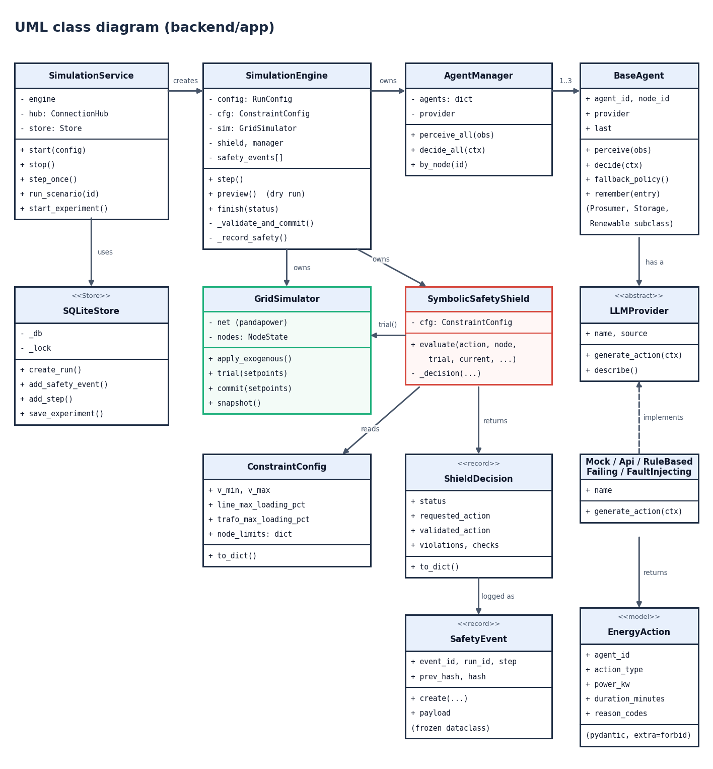
Figure 6: UML class diagram of the backend (backend/app)
SimulationService creates and controls the SimulationEngine and uses the SQLiteStore. The engine owns the AgentManager, the GridSimulator and the SymbolicSafetyShield. The manager holds the agents derived from BaseAgent (the prosumer, storage and renewable subclasses differ only in the extra context they add); each agent has an abstract LLMProvider, implemented by the mock, api, rule-based, failing and fault-injecting providers, which returns an EnergyAction. The shield reads a ConstraintConfig, calls GridSimulator.trial and returns a ShieldDecision; non-approved decisions are logged as SafetyEvent records whose prev_hash and hash fields form the chain.

Sequence diagram
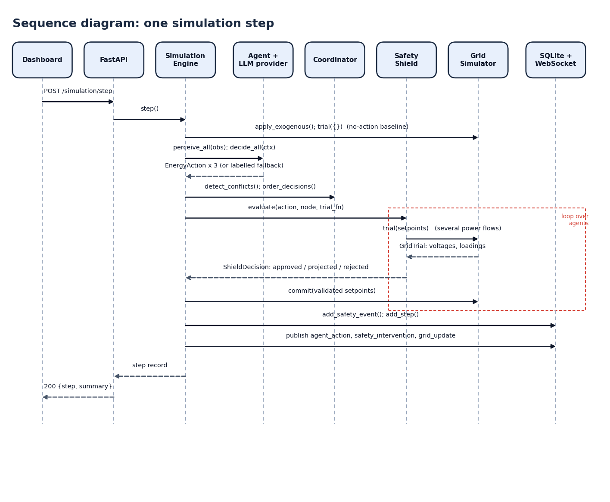
Figure 7: Sequence diagram: one simulation step
The dashboard posts to /api/simulation/step (a live run repeats the sequence in a background task). FastAPI calls step() on the engine, which applies the exogenous inputs, runs the no-action power flow, and calls perceive_all and decide_all on the agents; they return three actions. The engine detects conflicts, orders the proposals and calls evaluate on the shield for each in turn (the dashed frame); the shield calls trial on the grid simulator several times and returns a ShieldDecision. The engine commits the validated set-points, stores the safety events and the step, publishes agent_action, safety_intervention and grid_update events to the WebSocket clients, and returns the step record.

Use-case diagram
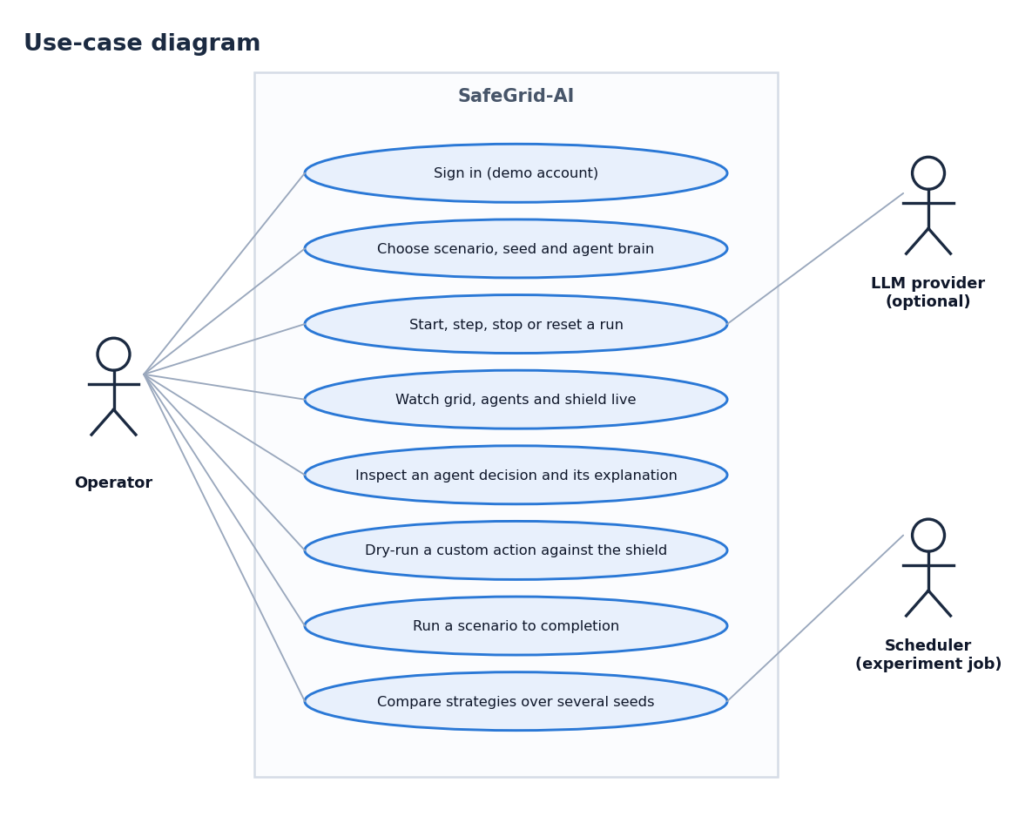
Figure 8: Use-case diagram
The operator can sign in with the demo account, choose a scenario, seed and agent brain, start, step, stop or reset a run, watch the grid, agents and shield live, inspect an agent decision and its explanation, dry-run a custom action against the shield, run a scenario to completion and compare strategies over several seeds. The optional LLM provider takes part in the run use cases by answering each agent's context; the experiment scheduler (a background job inside the service) takes part in the strategy comparison.

Entity-relationship diagram
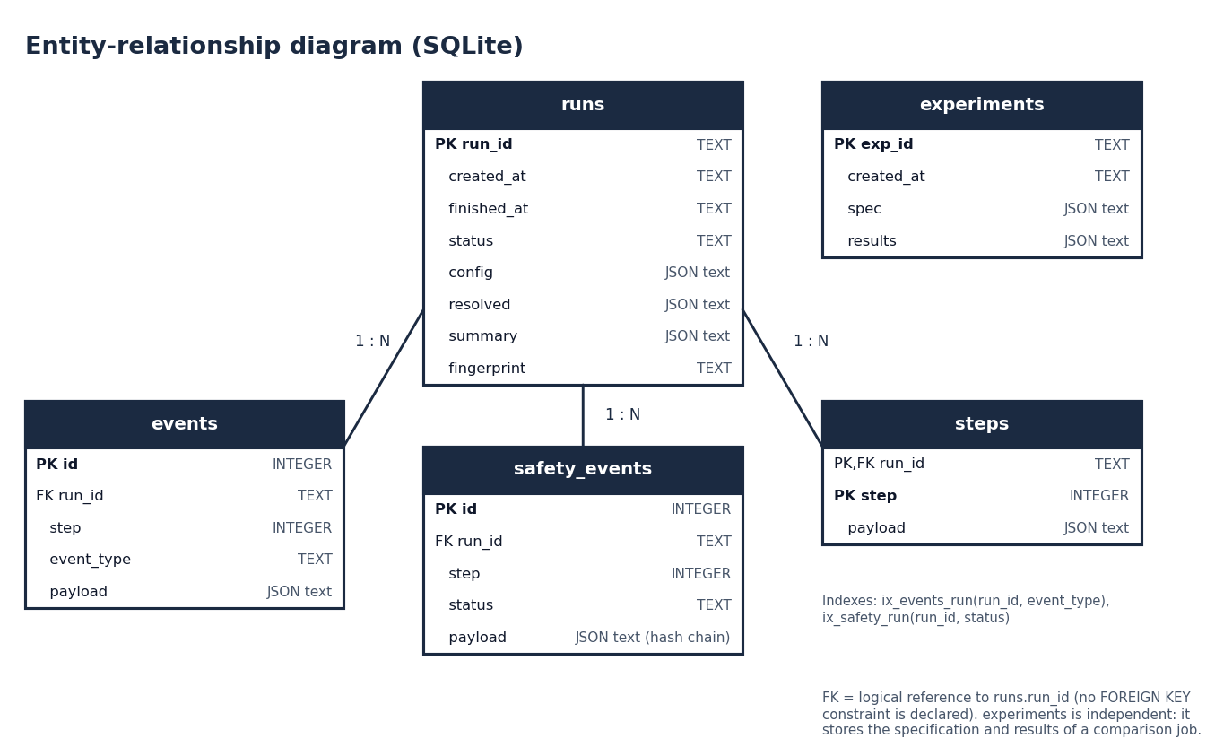
Figure 9: Entity-relationship diagram of the SQLite store
runs holds one row per simulation run, with its configuration, resolved settings, summary and the final hash of the safety chain. events (stream events), safety_events (non-approved decisions with their hash chain) and steps (one row per step) each reference a run by run_id, one run to many rows. experiments is independent: it stores the specification and aggregate results of a strategy comparison. Two indexes speed up the lookups of events and safety events by run.

Core algorithm flowchart
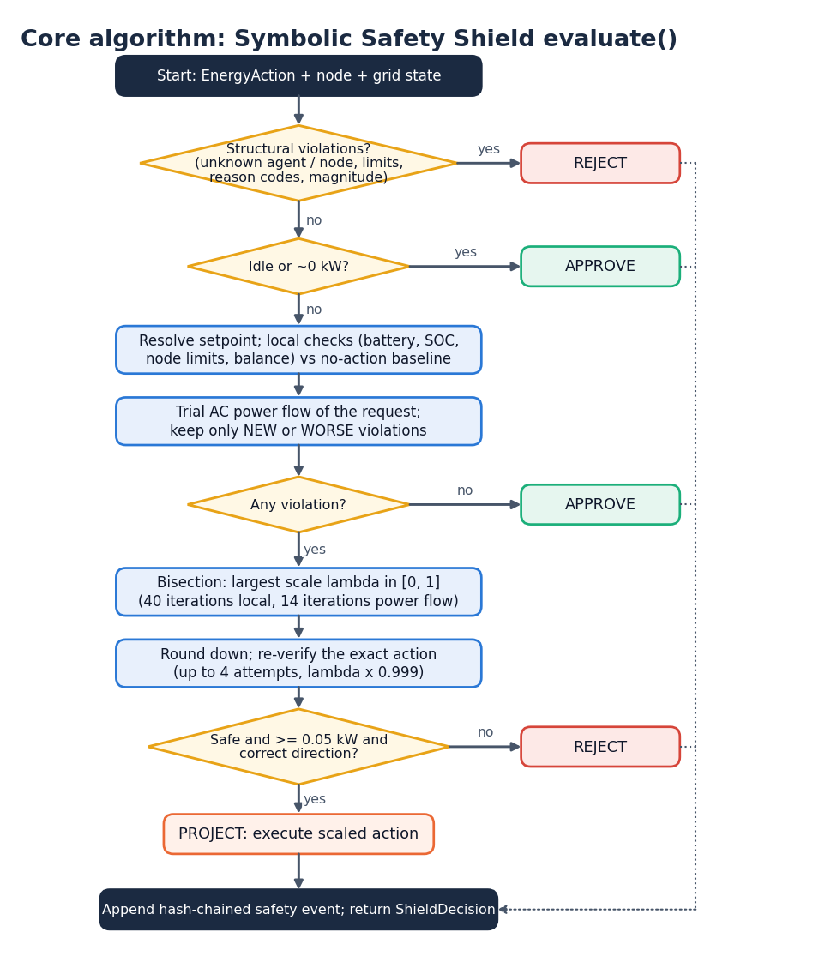
Figure 10: Core algorithm: Symbolic Safety Shield evaluate()
The flowchart follows the code in safety/shield.py. A structural violation (unknown agent or node, an agent acting on a node it does not own, a non-finite, negative or implausible power) rejects the action at once; an idle or zero-power action is approved. Otherwise the action becomes a physical set-point, the local checks (battery, state of charge, node limits, balance) and one trial power flow are run, and only violations that are new or worse than the no-action state count. With none, the action is approved. With some, a bisection (40 iterations for local limits, 14 for power-flow limits) finds the largest safe scale; the rounded action is re-verified up to four times; and the action is rejected if nothing safe remains, if the safe part is below 0.05 kW, or if an import or export target would change direction. Otherwise the scaled action is executed as a projection. Every outcome other than approval is appended to the safety log.

Simulated feeder topology
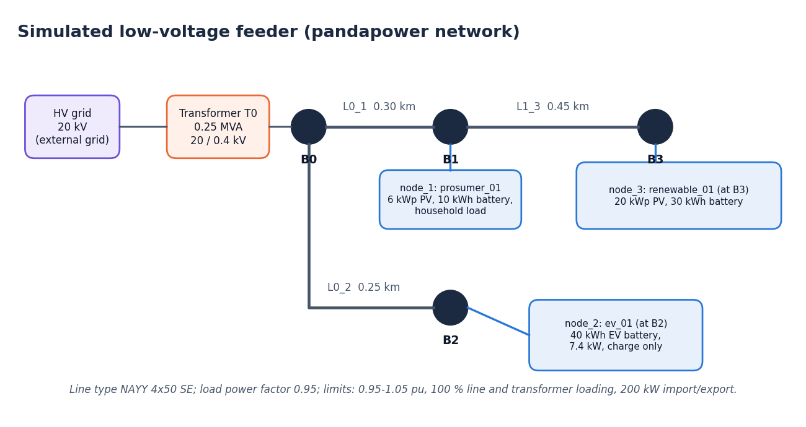
Figure 11: Simulated low-voltage feeder (pandapower network)
The simulated grid is a 20 kV external grid feeding a 0.25 MVA 20/0.4 kV transformer (T0) at bus B0. Line L0_1 (0.30 km) connects B0 to B1, where node_1, the residential prosumer (6 kWp PV, 10 kWh battery), is attached; line L1_3 (0.45 km) continues to B3, node_3, the renewable prosumer (20 kWp PV, 30 kWh battery); line L0_2 (0.25 km) connects B0 to B2, node_2, the EV (40 kWh battery, 7.4 kW, charge only). All lines are NAYY 4x50 SE cable and the load power factor is 0.95.

Hash-chained safety log
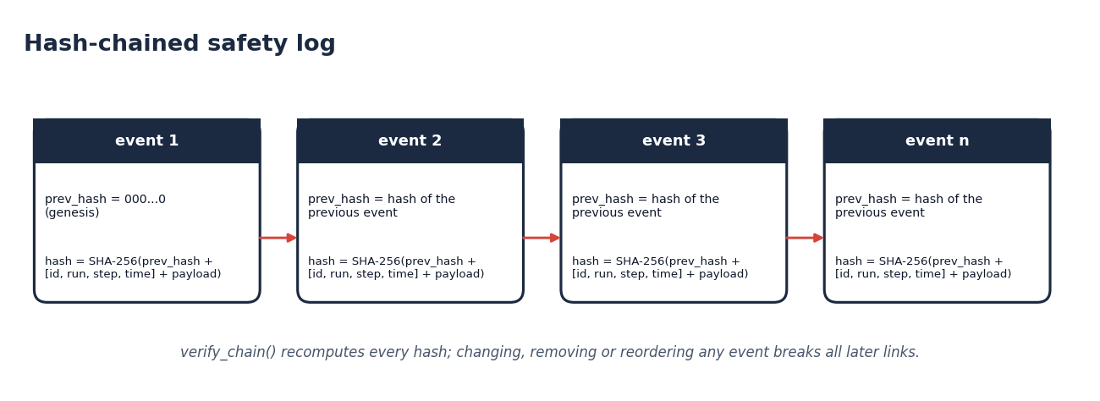
Figure 12: Hash-chained safety log
Each safety event stores the hash of the previous event (a string of zeros for the first) and its own SHA-256 hash over the previous hash, the identifiers [event id, run, step, simulated time] and the canonical payload. verify_chain recomputes every hash, so changing, removing or reordering any event breaks all later links. The wall-clock time is stored but excluded from the hash so that reruns are comparable.

